Grace Cole
Academic Teacher

Academic

BORCELLE UNIVERSITY
Bachelor of Art, 2012

RIMBERIO HIGH SCHOOL
Graduated Class of 2008

Work Experience

About Me
They are instrumental in shaping future generations, instilling not only academic knowledge but also values and life skills essential for success in the world.

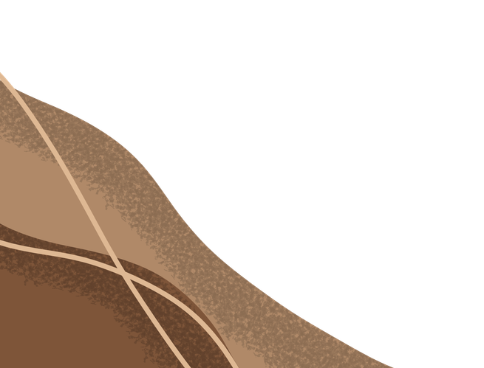





3RD GRADE TEACHER
2015 - now
Organizes all social media posts for the editorial department
Approves all content to be posted on social media

Skills
Adaptability Empathy Communication
Technology Proficiency

Contact
9999999999
hello@eConvert.org New York City

References
BENJAMIN SHAH
Senior Teacher | 9999999999
CHIDI EZE
Senior Teacher | 9999999999

