Owen Brooks

B A C K M E C H A N I C A L E N G I N E E R

A B O U T M E

I’m a professional back end engineer who has been working in the industry for over 3 years. I deal with complex issues efficiently.

C O N T A C T

9999999999

hello@eConvert.org

www.eConvert.org New York City

S K I L L S

Analytical & problem solving skills
90%

Communication team

95%

Ability to work in multiple projects

E D U C A T I O N

Borcelle High School (2011-2014) Borcelle University (2014-2018)
Bachelor’s Computer Engineering
GPA : 3.46

E X P E R I E N C E S

Back End Engineer (2018-2019)
Paucek and Lage
Generate recyclable code libraries Implement ongoing security systems Attend regular meetings with the front end team to expose weaknesses and problems
Routinely inspect server code for speed optimization

Back End Engineer (2020-now)
Arowwai Industries
Configure usability of all front side applications
Maintain a stable server with zero downtime
Keep a backup library before any large changes to server

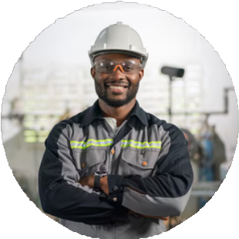
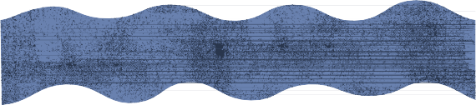




85%

