
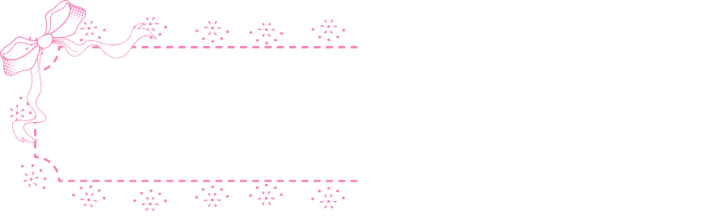
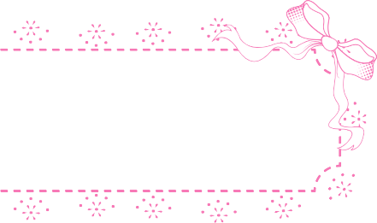

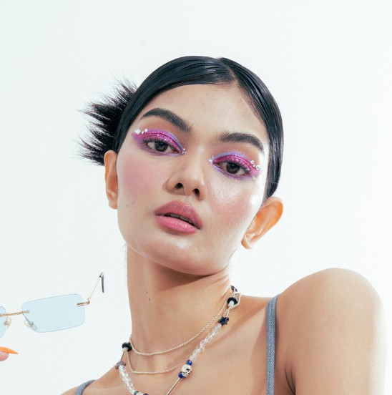
Profile Summary
Bella Skye
Freelance Model
hello@eConvert.org | 9999999999
Professional Freelance Model with experience in fashion, commercial, and promotional modelling projects. Confident in front of the camera, adaptable to different concepts, and comfortable working with creative teams to deliver strong visual results.

Education
Rimberio University 2020-2024

Work Experience
Freelance Model 2024-Present

Worked on fashion, lifestyle, and commercial photo shoots
Followed creative direction from photographers and stylists
Arrowai Model Agency
Worked on fashion, lifestyle, and commercial photo shoots
Followed creative direction from photographers and stylists

Skills & Expertise
Maintained professionalism during shoots and schedules
Collaborated with creative teams to achieve desired visuals
2023-Present
Maintained professionalism during shoots and schedules
Collaborated with creative teams to achieve desired visuals

Camera Confidence and Posing
Facial Expressions and Body Language
Adaptability to Creative Direction
Professional Attitude and Discipline

