
ANNA KATRINA MARCHESI
CERTIFIED NURSE

hello@eConvert.org 9999999999
New York City
@eConvert.org



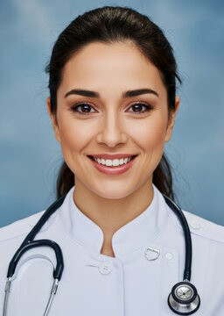
PROFESSIONAL SUMMARY

Highly skilled and dedicated Certified Nurse with over 5 years of experience in providing exceptional patient care.
Possess extensive knowledge in administering medication, monitoring vital signs, and managing patient records. Proven ability to work well under pressure and collaborate effectively with healthcare professionals to achieve positive patient outcomes.

SKILLS
Proficient in administering medication and treatments
Skilled in monitoring vital signs and assessing patient conditions Expertise in managing patient records and updating medical charts
Strong communication and interpersonal skills
Ability to work well under pressure and handle critical situations
Knowledge of infection control procedures and safety protocols Compassionate and patient-focused approach to care

LANGUAGES
English French Spanish Ukrainian

EDUCATION
Bachelor of Science in Nursing, Borcelle University, 2013 Registered Nurse certification, Paucek and Lage, 2012

WORK HISTORY

Certified Nurse, Ingoude Hospital, 2017-Present
Registered Nurse, Borcelle Medical Center, 2015-2017
Nursing Assistant, Keithston and Partners, 2013-2015

REFERENCES:

Available upon request.

