WORK EXPERIENCE

2019 - Present

2017 - 2018

2015 - 2016

Account Executive in Timmerman Industries
Handled client acquisition and servicing. Liaised between the clients and suppliers
Ensured customer satisfaction by handling day-to-day affairs

Account Handler in Timmerman Industries
Handled client acquisition and servicing. Liaised between the clients and suppliers
Ensured customer satisfaction by handling day-to-day affairs

Business Unit Manager in Borcelle
Manages a group of sales executives focused on client services Ensures adherence to the company code of conduct
Hire and train new personnels

EDUCATION PROFESSIONAL SKILLS

Fauget University
Bachelor of Business Management
2011 - 2014
Graduated with distinction, GPA 3.7 Won Young Entrepreneurs Challenge



CONTACT
Communication Interpersonal skills Time management Organization
Business Management




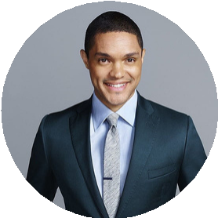




New York City
NICHOLAS
PIERCE
Professional Account Executive
9999999999
eConvert.org

