ALYSSA TURNER
Safety Mechanical Engineer

Key Skills

CAD Software Project Management Structural Analysis Process Optimization Team Collaboration
Safety & Compliance Standards

Education

Borcelle University (2031)

Bachelor of Science in Mechanical Engineering

Certification

Certified Professional Engineer (PE) – 2029

About Me
Innovative and detail-oriented Mechanical Engineer with over 6 years of experience in designing, testing, and optimizing mechanical systems.

Professional Experience

2032-Present

Senior Mechanical Engineer
Studio Shodwe
Designed mechanical components for manufacturing projects
Supervised a team of 5 engineers Improved delivery time by 15%.

2027-2032

Mechanical Engineer
Studio Shodwe
Prototyping for industrial machinery Supported automation adoption Reduced material costs by 12%.

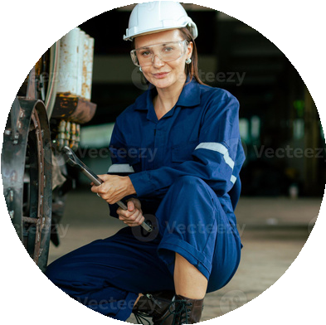

Contact Information
9999999999
hello@eConvert.org

