Olivia Martin
S T A F F A C C O U N T A N T

EDUCATIONS MY PROFILE

2011 - 2013 in University
Staff Accountant Major

2013 - 2015 in University
Staff Accountant Major
I am very professional working as a staff accountant. I have a lot of experience in this field. I have many skills in building my future career. I enjoy working in this job. This competition is to improve employee performance. The results assessed are from the creative of employees.

WORK EXPERIENCE

MY SKILLS

Graphic Design | 70 %
Creative | 85 %
Concepts  Photo Shoots | 90 %
Company Website | 75 %
User Interface | 80 %
Creative Idea | 80 %

CONTACT INFO

2015 - 2017
Staff Accountant in Company A
Work in accordance with the jobdesk provided by the company, and work on all client needs. Work with a
team and individually.

2017 - 2019
Staff Accountant in Company B
Work in accordance with the jobdesk provided by the company, and work on all client needs. Work with a
team and individually.

2019 - 2022
Staff Accountant in Company C
Work in accordance with the jobdesk provided by the company, and work on all client needs. Work with a
team and individually.

9999999999

hello@eConvert.org

AWARDS & ACHIEVEMENTS

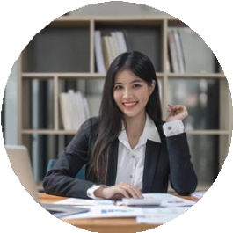
www.eConvert.org New York City

2018 Awards - Win 1 st Best Staff Accountant
This competition is to improve employee performance. The
results assessed are from the creative level of employees.

