



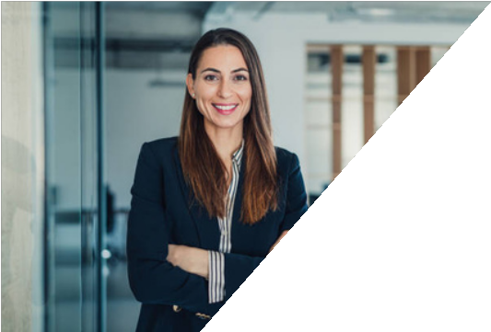
FIONA GRANT
EXPERIENCE
2018 - 2019
Larana Inc, Branding
Social Media Manager
Handling social media campaigns and Managing team to handling social media time line upload
2019 - present Shodwe Cosmetics
Digital Marketing Manager Managing oversees Company's digital marketing strategies to
reach more clients on the website
and social media.
CONTACT
9999999999
hello@reConvert.org www.eConvert.org New York City
DIGITAL MARKETING SPECIALIST
I’m Adora Montminy, a Digital Marketing Specialist with 4 years of experience. I’m specialist in handling and managing day to day team operation with considerable experience to read trends

EDUCATION
EXPERIENCE
2012 - 2015
Shodwe University
Bachelor Degree of Marketing and Business

2015 - 2018
Reallygreatsite University
Master Degree of marketing and Business

SKILL
Digital Marketing Tool
90%

Copywriting & Storywriting
80%

Digital Marketing Tool
77%

Search Engine Optimization
80%

Meta Tag Optimization
88%

