
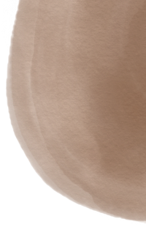
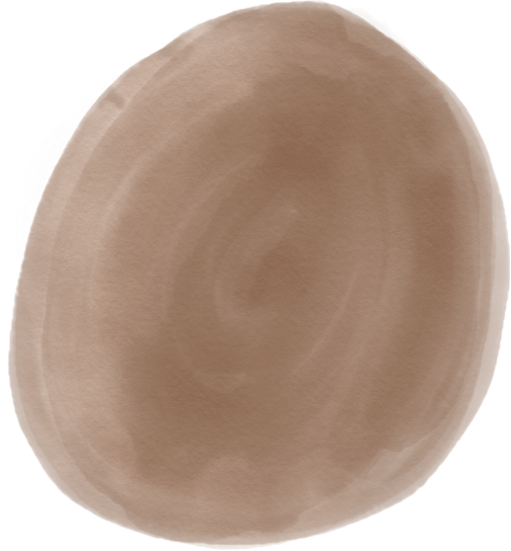
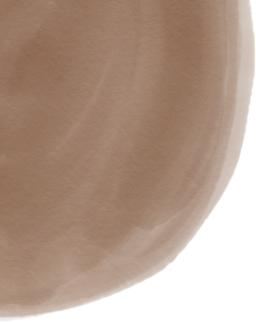
Experiences

Olivia
Napolitani
F\çRuo~ peçup~ec

Hello, I am a designer
I am a fashion designer who has 4 years of experience in this site. I have work for several fashion company industries.

Fashion Designer Assistant
Junior Fashion Designer
Senior Fashion Designer

Help the fashion designer to prepare things to exhibition
Make fashion design concept and assist to senior designer
Lead the fashion team to prepare annual fashion show

2010 - 2011 2012 - 2015 2016 - 2020

Educations

- Hanover and Tyke | Fine Art
- Warner & Spencer | Fashion Design
- Studio Shodwe | Fashion Business

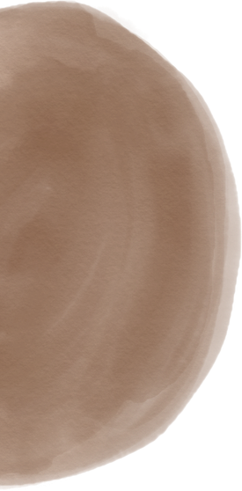
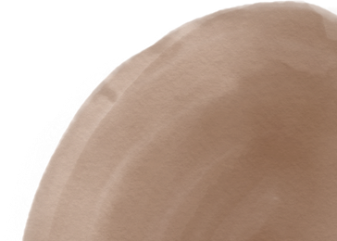
2009 - 2010
2010 - 2011
2011 - 2014
Soft Skills
Free hand fashion sketches
Making fashion show concept Time management
Contact Us
hello@eConvert.org
www.eConvert.org New York City

