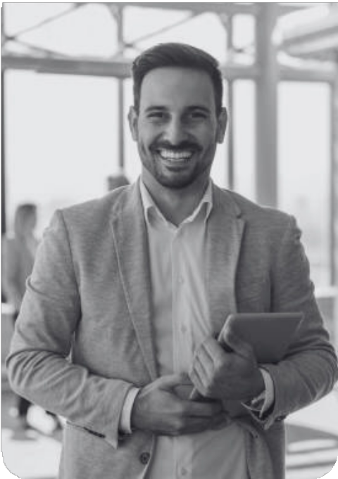
Hello, I am

PROFILE
Results-driven Digital Marketing Specialist with 5+ years of experience in SEO and content marketing.

MORGAN MAXWELL
Digital Marketing


9999999999 @eConvert.org



Work Experience
2023-2024
Digital Marketing Executive | Studio Shodwe
Increased organic traffic by 60% through on-page SEO
2017-2022
Digital Marketing Executive | Studio Shodwe
Increased organic traffic by 60% through on-page SEO




Education
CONTACT
hello@eConvert.org New York City
www.eConvert.org
Interest
Blogging Digital Trends
Hiking
2018
Bachelor of Business Administration
Borcelle University

Skills
Analytic
Content Planning Copywriting

