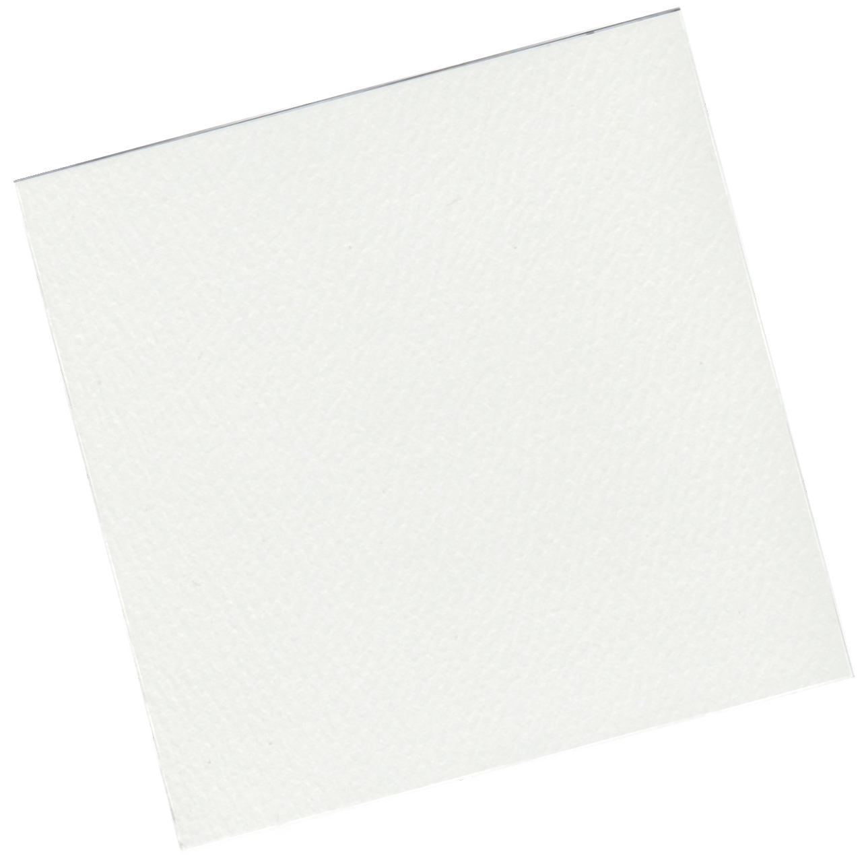

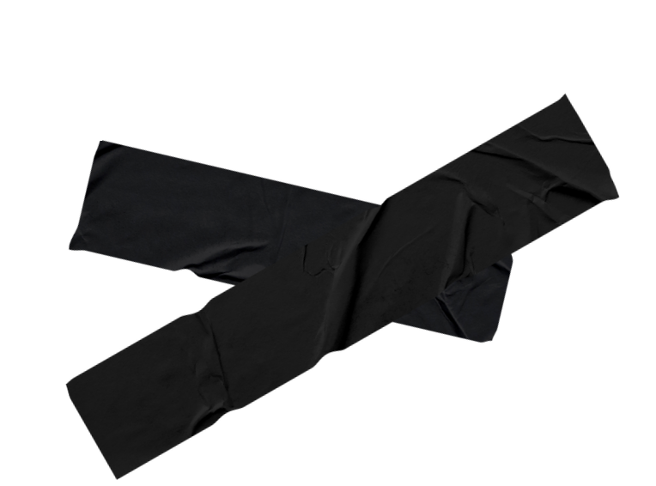


"Hello! I'm KETUT, a graphic designer who enjoys turning ideas into captivating visuals. I often create logos, posters, social media content. I also love exploring the latest design trends to keep growing. Excited to share and learn together!"
PORTFOLIO


CoNtact
9999999999


hello@eConvert.org www.eConvert.org


EduCation

LARANA UNIVERSITY
My
2011-2014 Graphic Design School

BORCELLE UNIVERSITY
2014-2018 Graphic Design School


Skill
Typography Color Theory
Layout Design Web Design
Logo Design

