JULIANA SILVA

Video Editor

About me
Creative and detail-oriented Video Editor with over 10 years of experience in producing high-quality videos for digital platforms, social media, and marketing campaigns. Skilled in video editing, color correction,
sound editing, and motion graphics. Seeking to leverage my skills and experience to create engaging content as a part of a dynamic team.

Work experience

Video Editor
Studio Shodwe / May 2021 - Present
Collaborated with creative teams and clients to develop video concepts, storyboards, and scripts, ensuring alignment with brand guidelines and objectives
Utilized software such as Adobe Premiere Pro, After Effects, and Final Cut Pro to perform tasks such as trimming footage, inserting dialogue, adding sound effects, and creating motion graphics.
Managed the full video production process from concept to final delivery, maintaining high standards of quality and attention to detail.

Junior Video Editor
Salford & Co. / April 2019 - April 2021
Assisted in the editing of 10 videos per week, focusing on promotional content and internal training videos.
Coordinated with the senior editing team to ensure all videos met technical standards and project deadlines.
Edited and synced audio to enhance the quality of dialogue, music, and sound effects. Created engaging motion graphics and visual effects using After Effects, contributing to a more dynamic viewer experience.


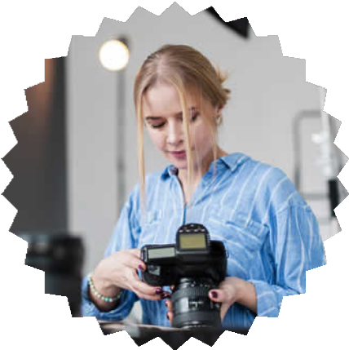
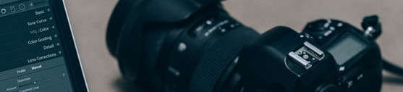
Skills
Video Editing Software: Adobe Premiere Pro, After Effects, Final Cut Pro, DaVinci Resolve
Motion Graphics: After Effects, Blender, Cinema 4D
Color Correction and Grading: Lumetri Color, DaVinci Resolve
Project Management: Ability to manage multiple projects and meet tight deadlines

Education
Bachelor of Arts in Film and Media Studies University of ABC, City, State

Contact
99999999999
hello@eConvert.org www.eConvert.org @eConvert.org

