
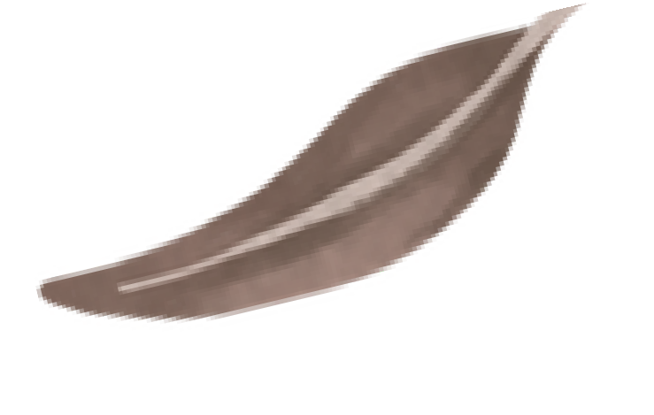
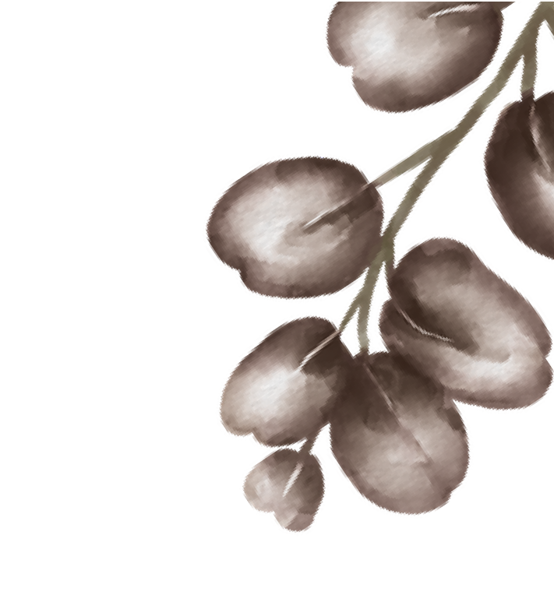
SACHA DUBOIS
FAS HI ON DES I G NER
Fashion designer is who have skill to design clothes from woman, man and children. and I have 6 years experience for designing fashion and forecasting what will be popular with consumers

EXPERIENCE

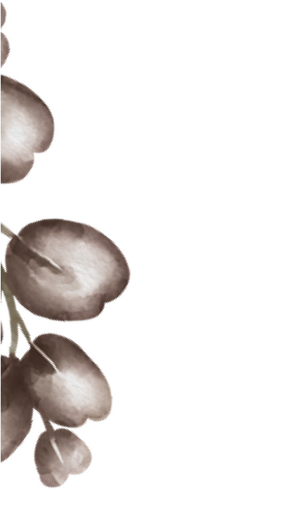
2018 - 2019
CONTACT
+123-456-7890
hello@reallygreatsite.com www.reallygreatsite.com
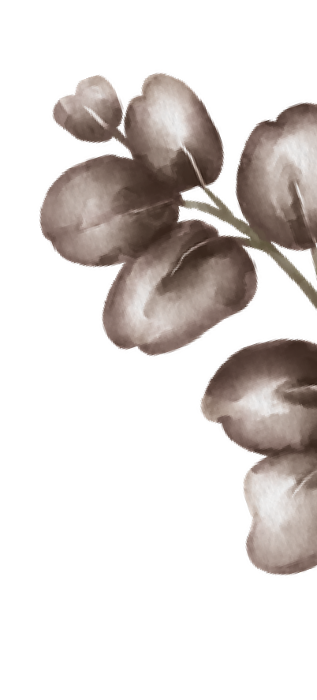
Freelance Fashion Designer
Drawing and Sketching idea or concept of clothing to client’s request

123 Anywhere St., Any City

SKILLS
Fashion Illustration Drawing Sketch
Digital Fashion Drawing Trend Forecasting
2019 - present Liceria Company
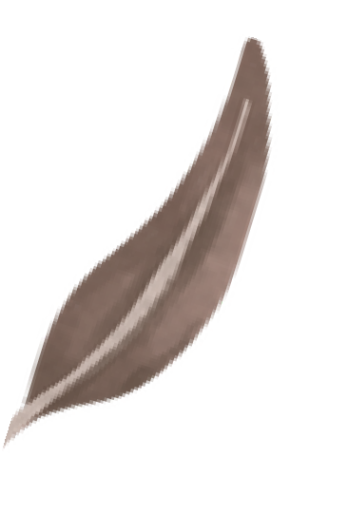
FASHION DESIGNER
Drawing and sketching clothes, accesories, or shoes for consumer and retail companies
Forecasting what will be popular with costumer in one year ahead
Managing team to apply fashion sketch to assemble cloth and it's accesories
Colaborating with the wider development team and buyer to develop products

EDUCATION
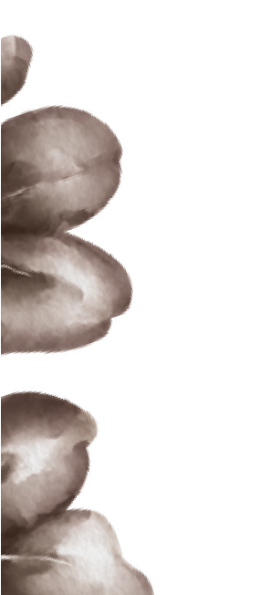
2014 - 2015 :
AWARD
2019 : Best Fashion Designer Given by Salford Magazine
Shodwe Certified Academy
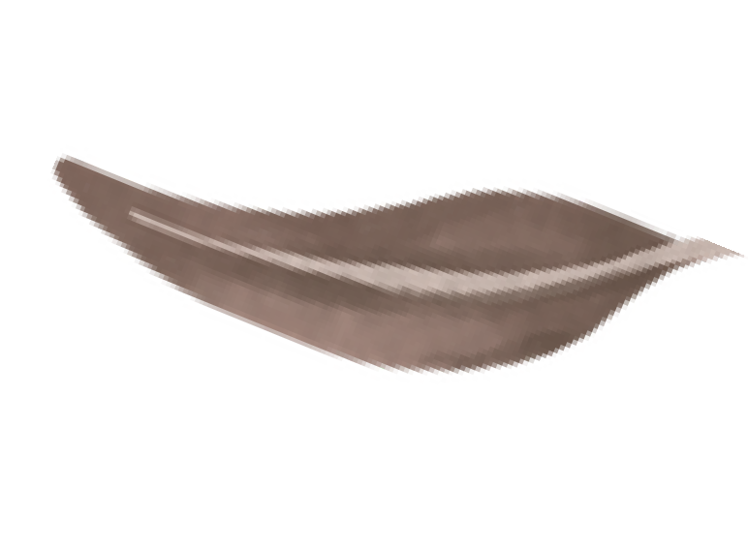
Fashion Design
2015 - 2018 :
Larana University
Bachelor Degree of Fashion Design

